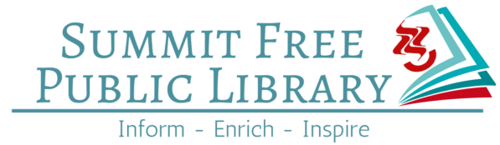

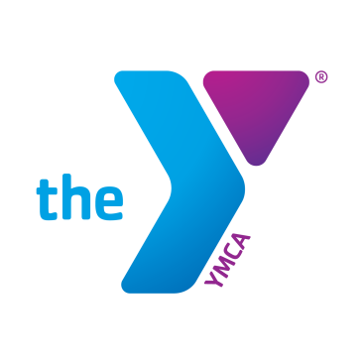
To learn more about Togetherhood™, visit
THESAY.ORG/TOGETHERHOOD

Learn how to write and publish your own story. Guest speaker and publisher Henry M. Quinlan, who has more than 40 years publishing experience, will lead this exciting and informative presentation.
Learn more about Henry M. Quinlan at www.bookpublishing.omni-pub.com

Brought to you by The Summit YMCA Togetherhood™ Committee
and The Summit Free Public Library

- Date: Wednesday May 24, 2017
- Where: Summit Free Public Library
75 Maple Street, Summit, NJ 07901
- Times: Session one: 1:00-2:30pm (Hickock Room)
Session two: 7:00-8:30pm (Lower level)
Please RSVP on the library website:
http://www.summitlibrary.org/events-programs​
Click on May 24 and pick session.
Questions: Please contact Lisa Meyers
908-273-3330 X1186
WRITE YOUR STORY & PUBLISH TOO!

